A000-Afr-Gabon-Vouvi Door-Early 20th c

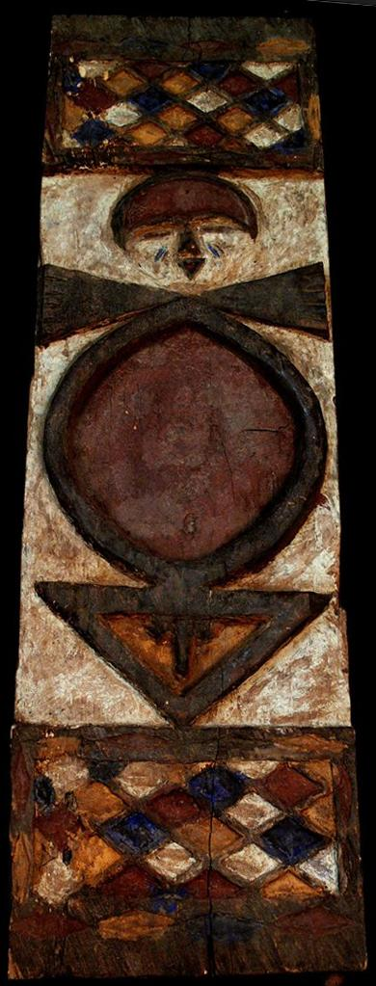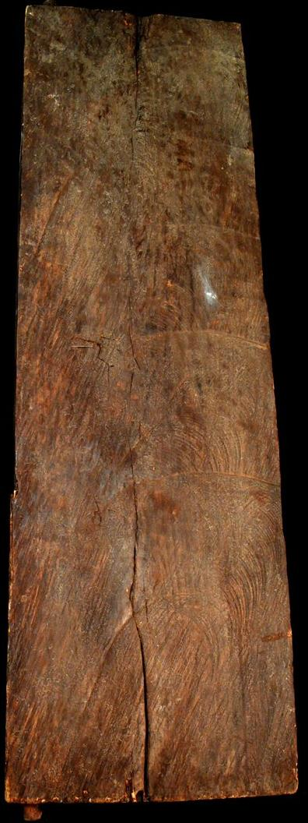

Case No.:

**Accession No.**

**Formal Label:**

**Display Description:**

**LC Classification:**

**Date or Time Horizon:**

**Geographical Area:**

**Map:**

**GPS coordinates:**

**Cultural Affiliation:**

**Media: wood, kaolin pigments**

**Dimensions:** 38.976 in

**Weight:** 11.811 pounds

**Condition:**

**Provenance:**

**Discussion:**

**References:**